1. Check the git version

git --version

2. assign username

git config --global user.name Arvind

3. assign email

git config --global user.email "arvinduttam25@gmail.com"

4. check git config details

git config --list

5. Check git status

git status

6. Initiate the Git

git init

7. add in staging

git add --a

8. commit the changes

git commit -m "Initail Commit"

9. check the log

git log // simple all the logs

git log -p // logs in details of changes

git log --stat // give details in short

git log –pretty=short

git log –pretty=full

10. disbale the git for that folder

rm -rf .git

11. Clone any repository from hit hub

git clone https://github.com/rogerperkin/network-programmability.git

12. to fix the certificate issue

error

fatal: unable to access 'https://github.com/rogerperkin/network-programmability.git/':

SSL certificate problem: unable to get local issuer certificate

solution

git config --global http.sslbackend schanne

git config --global http.sslcainfo /mingw64/ssl/certs/ca-bundle.crt

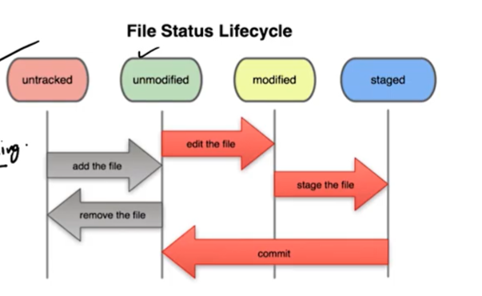

1. Initially new folder as not a git repository

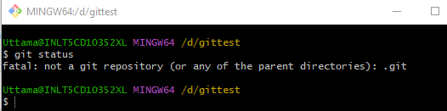

1. Run the git init

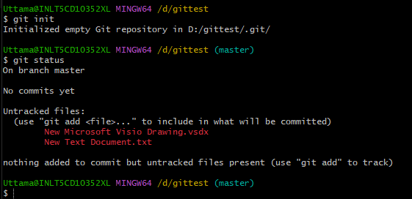

All the files and folders moved into untracked, and this become a git repository

1. Run the git add –a

Then files become staged and unmodified

1. Make changes in file

Then files become in Modified

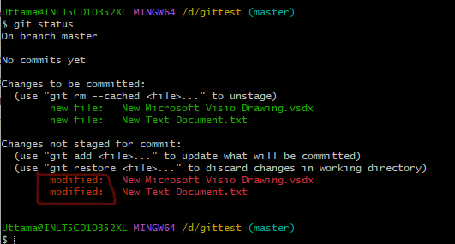

1. Run the git add –a

Then files become staged and unmodified

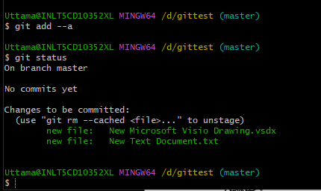

1. Git commit: Snapshot is created for this repository and showing working tree is clean.

Note: if we do changes in any file then this file will show as modified but without doing add -a we do commit then it takes the snapshot of an old version of the unchanged file if we add -a and then commit, this will take a snapshot of the modified file.

1. To ignore any file in git
2. Create .gitignore file and put the file name need to ignore

Eg:

Error.log // for single file

*.log // for all the files having log extension.

Dir/ // to ignore all the folders with Dir

/Dir/ // to ignore Dir folder outside only

If we made any changes in error.log file then git will ignore that file.

1. To check the difference.

(a)

Command: get diff

Get diff command to give difference between the staging Area and working directory

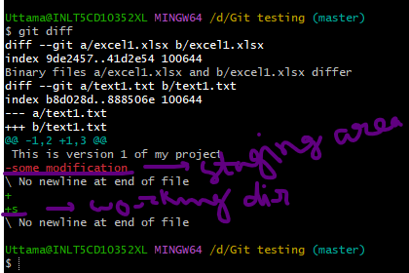

Command: git diff –staged

This command is compared between the previous commit and the current staging area

1. To commit directly without a staging area

Command: get -a -m “ This is a direct commit”

Note: Untracked file will not commit and need to be untracked file first to move in stating area.

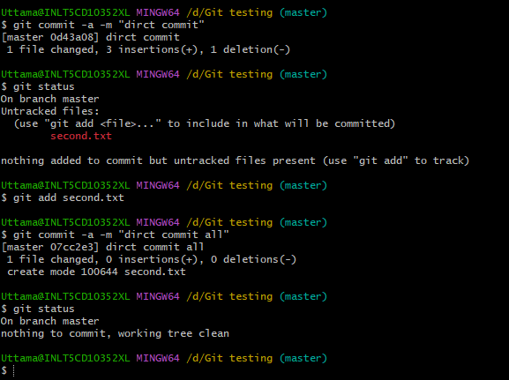

1. To delete / rename the file

Current no change

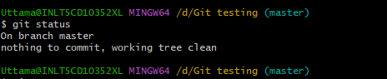

Then manually delete the second.txt file from directory

This is not in the staging area and we need to run the git add -a command to move this in stating area

But if we delete the file from git command then it will go directly staging area

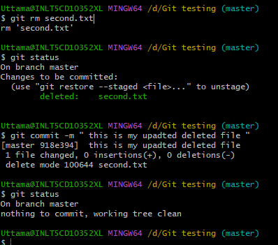

For rename the file use git command as well

Command: git mv second.txt second_rename.txt

1. Revert to the working directory to previous commit.

Commit : git checkout -f